South Dakota School of Mines and Technology
Department of Materials and Metallurgical Engineering

MET 320 HQ 4 Dec 11, 2003
Closed Book and Notes No Calculators Data Sheet Provided MET 320

R = 1.987 cal/K•gmole = 8.31 J/K•gmole
F = 23,060 cal/volt•gram equivalent = 96,259 cal/volt•gram equivalent

- Set up a reaction extent problem for

3H₂ + N₂ = 2 NH₃ K_{EQ} = 1.2 P_{T} = 5 atm

The table below shows the number of moles of each component initially.
Species | Moles initially
NH₃ | 2
H₂ | 1
N₂ | 1
total | 4

Use the attached Ellingham Diagram for the problems below.

(Show your work and submit the Ellingham Diagram.)
- Show on the attached Ellingham Diagram

- The pressure of O₂ in equilibrium with Ca and CaO at 1000°C

- The H₂/H₂O ratio in equilibrium with Si and SiO₂ at 1000°C

- The value for Standard Gibbs Energy change for the formation of one mole of TiO₂ at 1000 °C.

Refer to the data for the Al-Au system at the end of the exam for Problems 3 and 4

- Calculate the Gibbs energy change for the oxidation of liquid Al in a liquid Al-Au alloy at a mole fraction of 0.1 with O₂ at a pressure of 1x10⁻¹² ATM to form pure, solid Al₂O₃ _{oxide}. The temperature is 1338 K (1611 ºC).

2/3 Al_{(l)} + O_{2(g)} = 4/3 Al₂O₃ (s) ΔG°= -711,620 Joules/gmole O₂

4. How much heat would be expected from mixing
- 2 moles of liquid Al at 1338 K and 8 moles of liquid Au at 1338 K?

- 1 mole of liquid Al at 1338 K and 1,000,000 moles of liquid Al-Au alloy of X_{Al} = 0.7 at 1338 K?

5. What voltage would be needed to form pure, liquid Mg from a cell at 800 K from pure, liquid MgCl₂ The pressure of Cl₂ is 0.1 atm?

MgCl2(l) = Cl2(g) + Mg(l) ΔG°= 605,000 -125.4T J/gmole

6. Fill in the blank.

To obtain in a binary alloy | Given | Use Method  or  Equation
The Integral Molar Quantity | The Partial Molar Quantities
The Partial Molar Quantity #1 | The Partial Molar Quantity #2
Both Partial Molar Quantities | The Integral Molar Quantity
DATA from Hultgren, et al. All G and H data are in calories. All S data are in calories/K
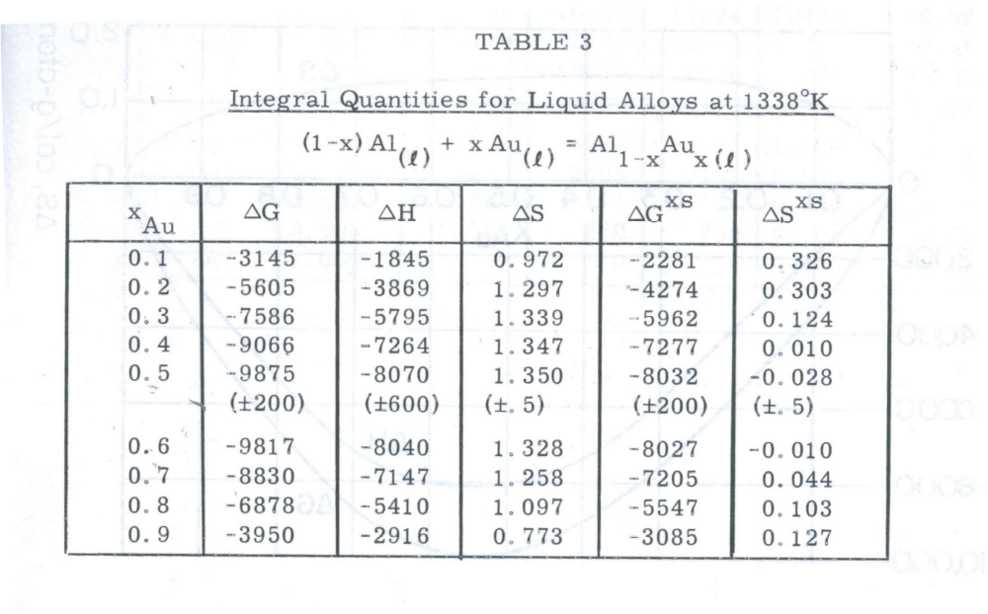
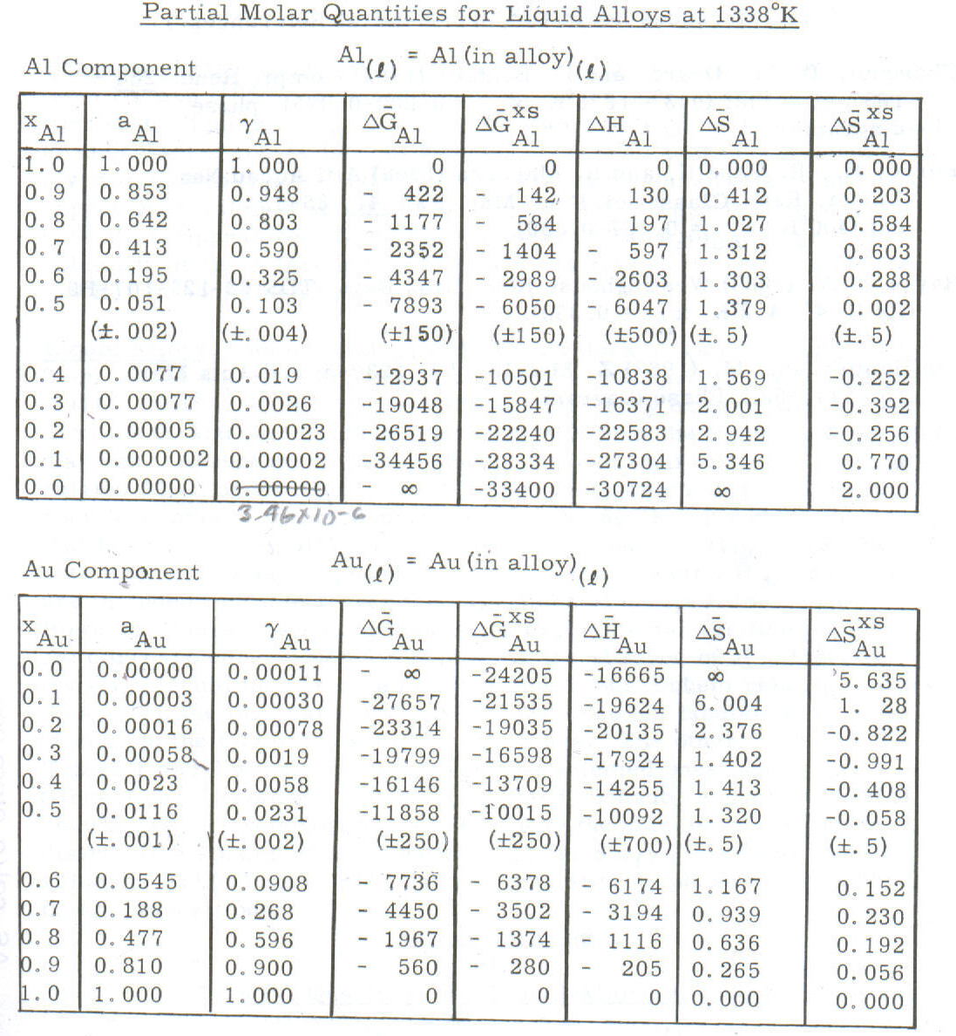
0.0000035

