MET 320 HQ 3 Dec 7, 2009
Closed Book and Notes No Calculators Data Sheet Provided

R = 1.987 cal/K•gmole = 8.31 J/K•gmole
F = 23,060 cal/volt•gram equivalent = 96,259 cal/volt•gram equivalent

6 Questions

- Short answer
- What is the difference between ΔG and ΔGº?

- What is the relative partial molar heat of mixing for an ideal solution?

- What is the definition of the activity coefficient, γ_{i}?

- What is the name of the equation that relates the changes of partial molar solution quantities?

2. Show how to find the Gibb’s Energy change and direction of the reaction at 1100 K for

PbO_{(l)} + SO₂ + ½ O₂ = PbSO_{4(s)} (see data sheet for data)

when the pressure of SO₂ is 0.1 atm; the pressure of O₂ is 2 atm; the activity of PbO is 0.1 relative to pure, liquid PbO; and the PbSO₄ is pure solid.

- If ΔG° for the molten salt electrolysis of NaCl at 1100 K by the reaction

NaCl2(l)= 0.5Cl2(g) + Na(l)
is +74,000 cal/gmole, what voltage would be required to make pure, liquid Na and chlorine gas at 1 atm from pure, molten NaCl?

4. Using the supplied Ellingham Diagram find
(Show your construction lines or other identifying marks on the attached diagram)
- The pressure of O₂ in equilibrium with V and V₂O₃ at 1400°C.
Ans:

- The H₂/H₂O ratio in equilibrium with V and V₂O₃ at 1400°C.
Ans:

- If pure Ni and NiO were in the same reactor at 1200 °C with pure Al and pure Al₂O₃,
what would happen as the system achieved equilibrium? (Circle all correct answers)
  - The Ni would be oxidized while Al₂O₃ was reduced.
  - The Al would be oxidized while the NiO was reduced
  - Both Al and Ni would be oxidized further
  - The system would not react since both reactions would be at equilibrium

- What is the melting point of Ca? (Circle the location on the diagram.).
Ans:

- Estimate the 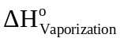 of one mole of Zn_{(l)}.
Ans:

5. Set up a reaction extent problem for

SO₂ + 0.5 O₂ = SO₃

if there are initially 14 moles of SO₂, 3 moles of O₂, and no SO₃. The K is 0.8 and the total pressure is 4 atm.

6. Use the data sheet provided for the Ag-Al system. How much heat would be expected from mixing
a) 2 moles of liquid Al at 1338 K and 8 moles of liquid Au at 1338 K?

  - 1 mole of liquid Al at 1338 K and 1,000,000 moles of liquid Al-Au alloy of X_{Al} = 0.1 at 1338 K?

DATA from Hultgren, et al. All G and H data are in calories. All S data are in calories/K
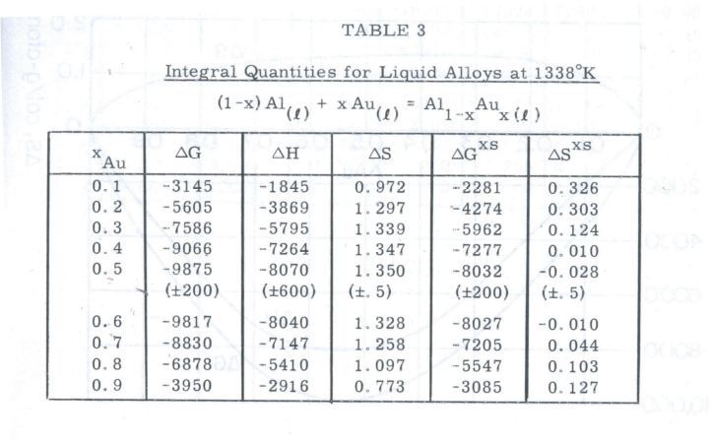

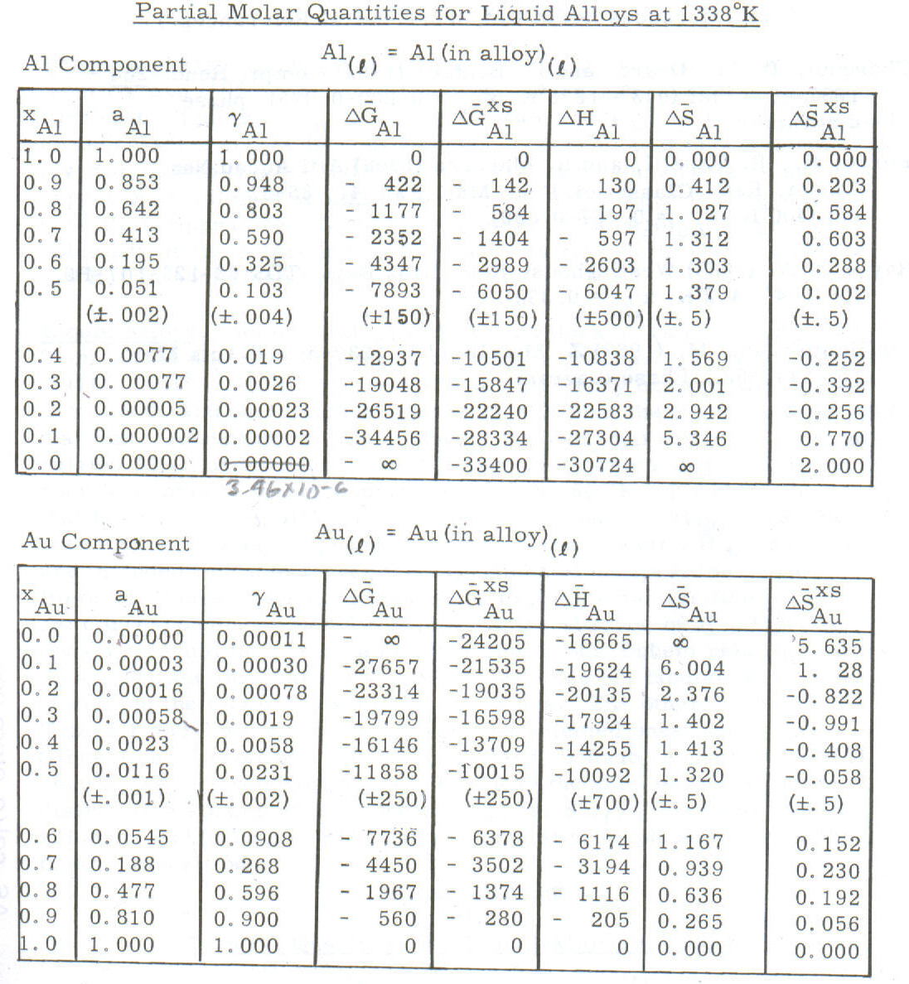
0.0000035

