South Dakota School of Mines and Technology
Department of Metallurgical Engineering

MET 320 HQ 3 Dec. 7, 2010
Closed Book and Notes No Calculators Data Sheet Provided

Constants:
R = 1.987 cal/K•gmole = 8.31 J/K•gmole
F = 23,060 cal/volt•gram equivalent = 96,259 cal/volt•gram equivalent

- Ellingham Diagram: find
- The pressure of O₂ in equilibrium with Si and SiO₂ at 1000°C. (Show work.)
Ans:

- The H2/H₂O ratio in equilibrium with Si and SiO₂ at 1000°C. (Show work.)
Ans:

- Which of the following pure oxides could be reduced to pure metal by C at 1000°C at a total pressure of 1 atm?
MgO, SnO_{2,} PbO, Cr₂O₃ .
Ans:

- What is the melting point of Mg? (Circle the location on the diagram.).
Ans:

- Estimate the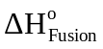of one mole of Zn. (Show construction lines.)
Ans:

2. Use the data given below for the liquid Al-Au system at 1338 K to determine the enthalpy change when (assume all components start in the liquid state at 1338 K)
- 3 moles of Au are dissolved in a very large quantity of Al-Au alloy having a mole fraction of Au of 0.3.

- 40 moles of pure, molten Al and 60 moles of pure, molten Au are mixed at 1338 K

DATA from Hultgren, et al. All G and H data are in calories. All S data are in calories/K
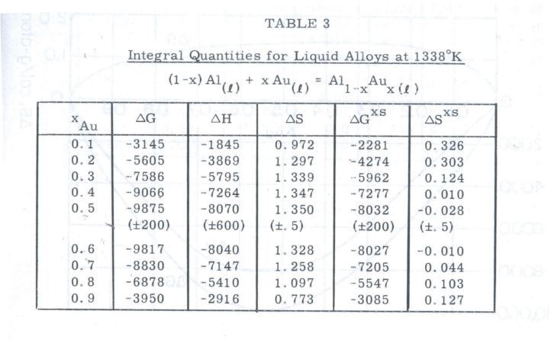

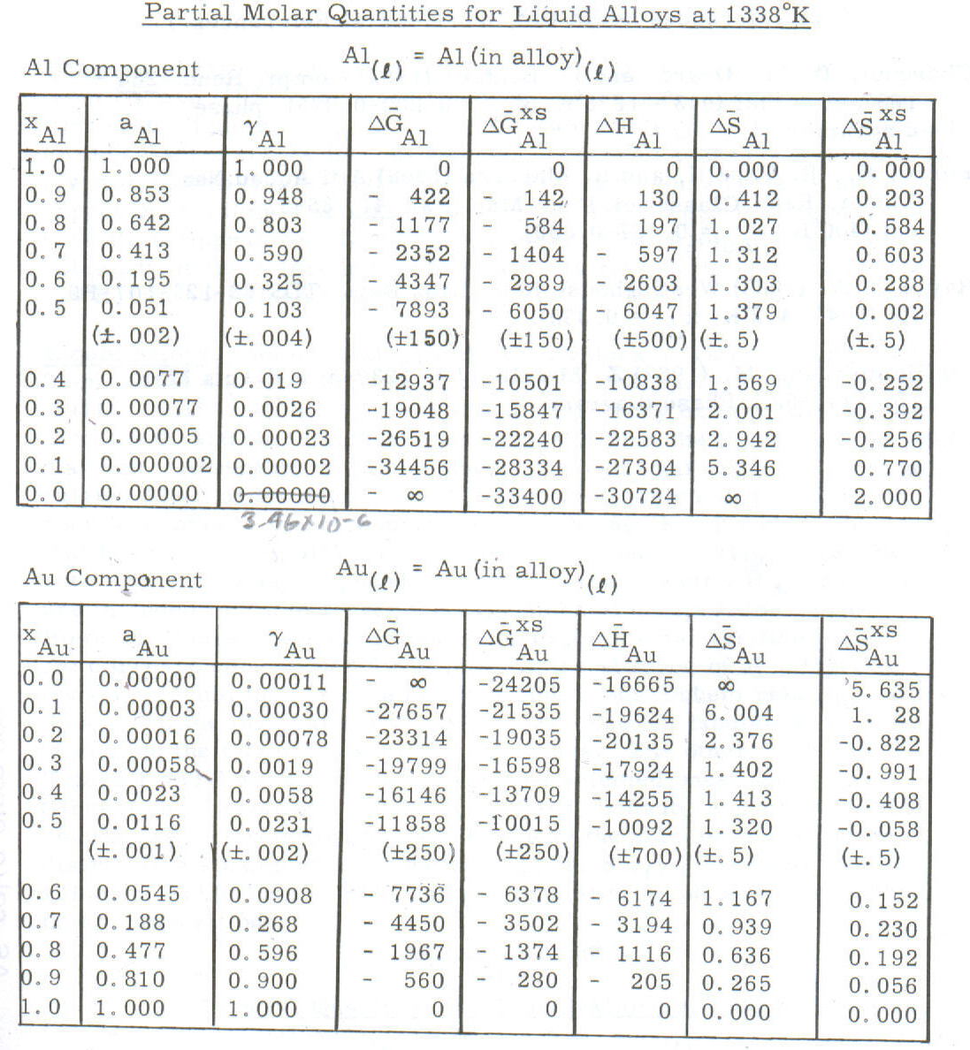
0.0000035

3. Calculate Gibbs energy change when one mole of pure, liquid Cu at activity of 0.1 reacts with O₂ at 10⁻⁶ atm to form pure, solid Cu₂O at 1423 K.

4. What voltage would be required to produce at 1125 K pure, liquid Ca and chlorine gas at 0.2 atm from pure, molten CaCl₂ with an activity of 0.4 relative to pure, liquid CaCl₂?

CaCl2(l)= Cl2(g) + Ca(l) ΔG° = +625,000 J/gmole at 1125 K

5. How many degrees of freedom are there in a system comprised of the following?
a) Pure liquid Cu, pure solid C and Cu₂O, and CO gas.

b) Pure solid C, pure liquid Pb, pure solid PbO, and CO gas.

c) Pure solid C, pure liquid Pb, pure solid PbO, CO gas, and CO₂ gas.

d) Solid C, liquid Cu with some Ag dissolved in it, pure solid Cu₂O, and CO gas.
Scratch Paper - discard

