Assignment 2: The Design Process- Statement and Requirements
Submit digitally before noon Wednesday 1-25-19
(Always submit these Assignment Sheets on top of your submissions.)

For your assigned design project

- State the problem: Write a clear, concise statement summarizing your view of the problem for which you are designing a solution.
- Identify your customers/stakeholders: Provide a brief statement specifying your customer/stakeholders for this project.
- Determine customer requirements, both needs and expectations: Write a paragraph indicating the requirements, needs and expectations you have identified at this time. Keep in mind, good requirements should be achievable, verifiable, unambiguous, complete and consistent.
- Identify cost, schedule and performance constraints: Provide a brief statement specifying your cost schedule and performance constraints.
Note: As students learning the design process, you may think of this exercise as the writing of the design project statement complete with the stakeholders, constraints, and requirements. The initial design statement is intentionally vague.

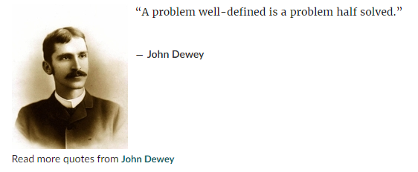https://www.goodreads.com/quotes/7702317-a-problem-well-defined-is-a-problem-half-solved

