South Dakota School of Mines and Technology
Department of Materials and Metallurgical Engineering

Met 321 HQ 1 2/14/2003

- Questions on Cost, Conservation, and Concentration
a. Sketch a curve showing how the amount of mineral resource changes with grade.
Increasing Grade
Reserves

b. Sketch a curve showing the Mass of material used per unit Gross Domestic Product for a nation as a function of its per capita Gross Domestic Product.
Mass of material consumed per unit of Gross Domestic Product
Per capita Gross Domestic Product

c. Sketch the trend of inflation-adjusted unit cost of a typical metal during the 20th Century
Unit Cost
Time

d. Sketch the total amount of Cu (as elemental including compounds) on Earth over the 20th Century

Amount

Time

2. Determine the degrees of freedom in each of the following systems:
a) Solid austenitic Fe, solid C, gaseous CO plus CO₂ at a total pressure of 1 atm.

b) What if a second phase of alpha Fe is added to system (a) above?

- The three solids: MgO, SiO₂, and CaO at 1 atm

- A system at a fixed temperature and consisting of ZnS, ZnO, SO₂, and O₂.

- A Stability Diagram (also known as a Predominance Diagram) is being constructed for the hypothetical M-O-Cl system. On the chart below, write the approximate, relative positions of each of the following condensed phases:
M MO MOCl MCl
M₂O MO₃ MOCl₂ MCl₂

Log P_{O2}
Log P_{Cl2}

4. Refer to Problem #3. Assuming the following phases are adjacent (i.e. in equilibrium), what is the slope of the line between
- M₂O and MO₃

- MOCl₂ and MCl₂

- M and MOCl

5. Refer to the attached ternary Phase Diagram for the MgO - SiO₂ - CaO (M, S, C) system. Characterize a batch composition of 40 wt% M and 10 wt % S at

- 2200 °C
- 2000 °C
- 1800 °C

Show all your work on the following diagrams as indicated. Use symbols for lengths.
a) 2200 °C

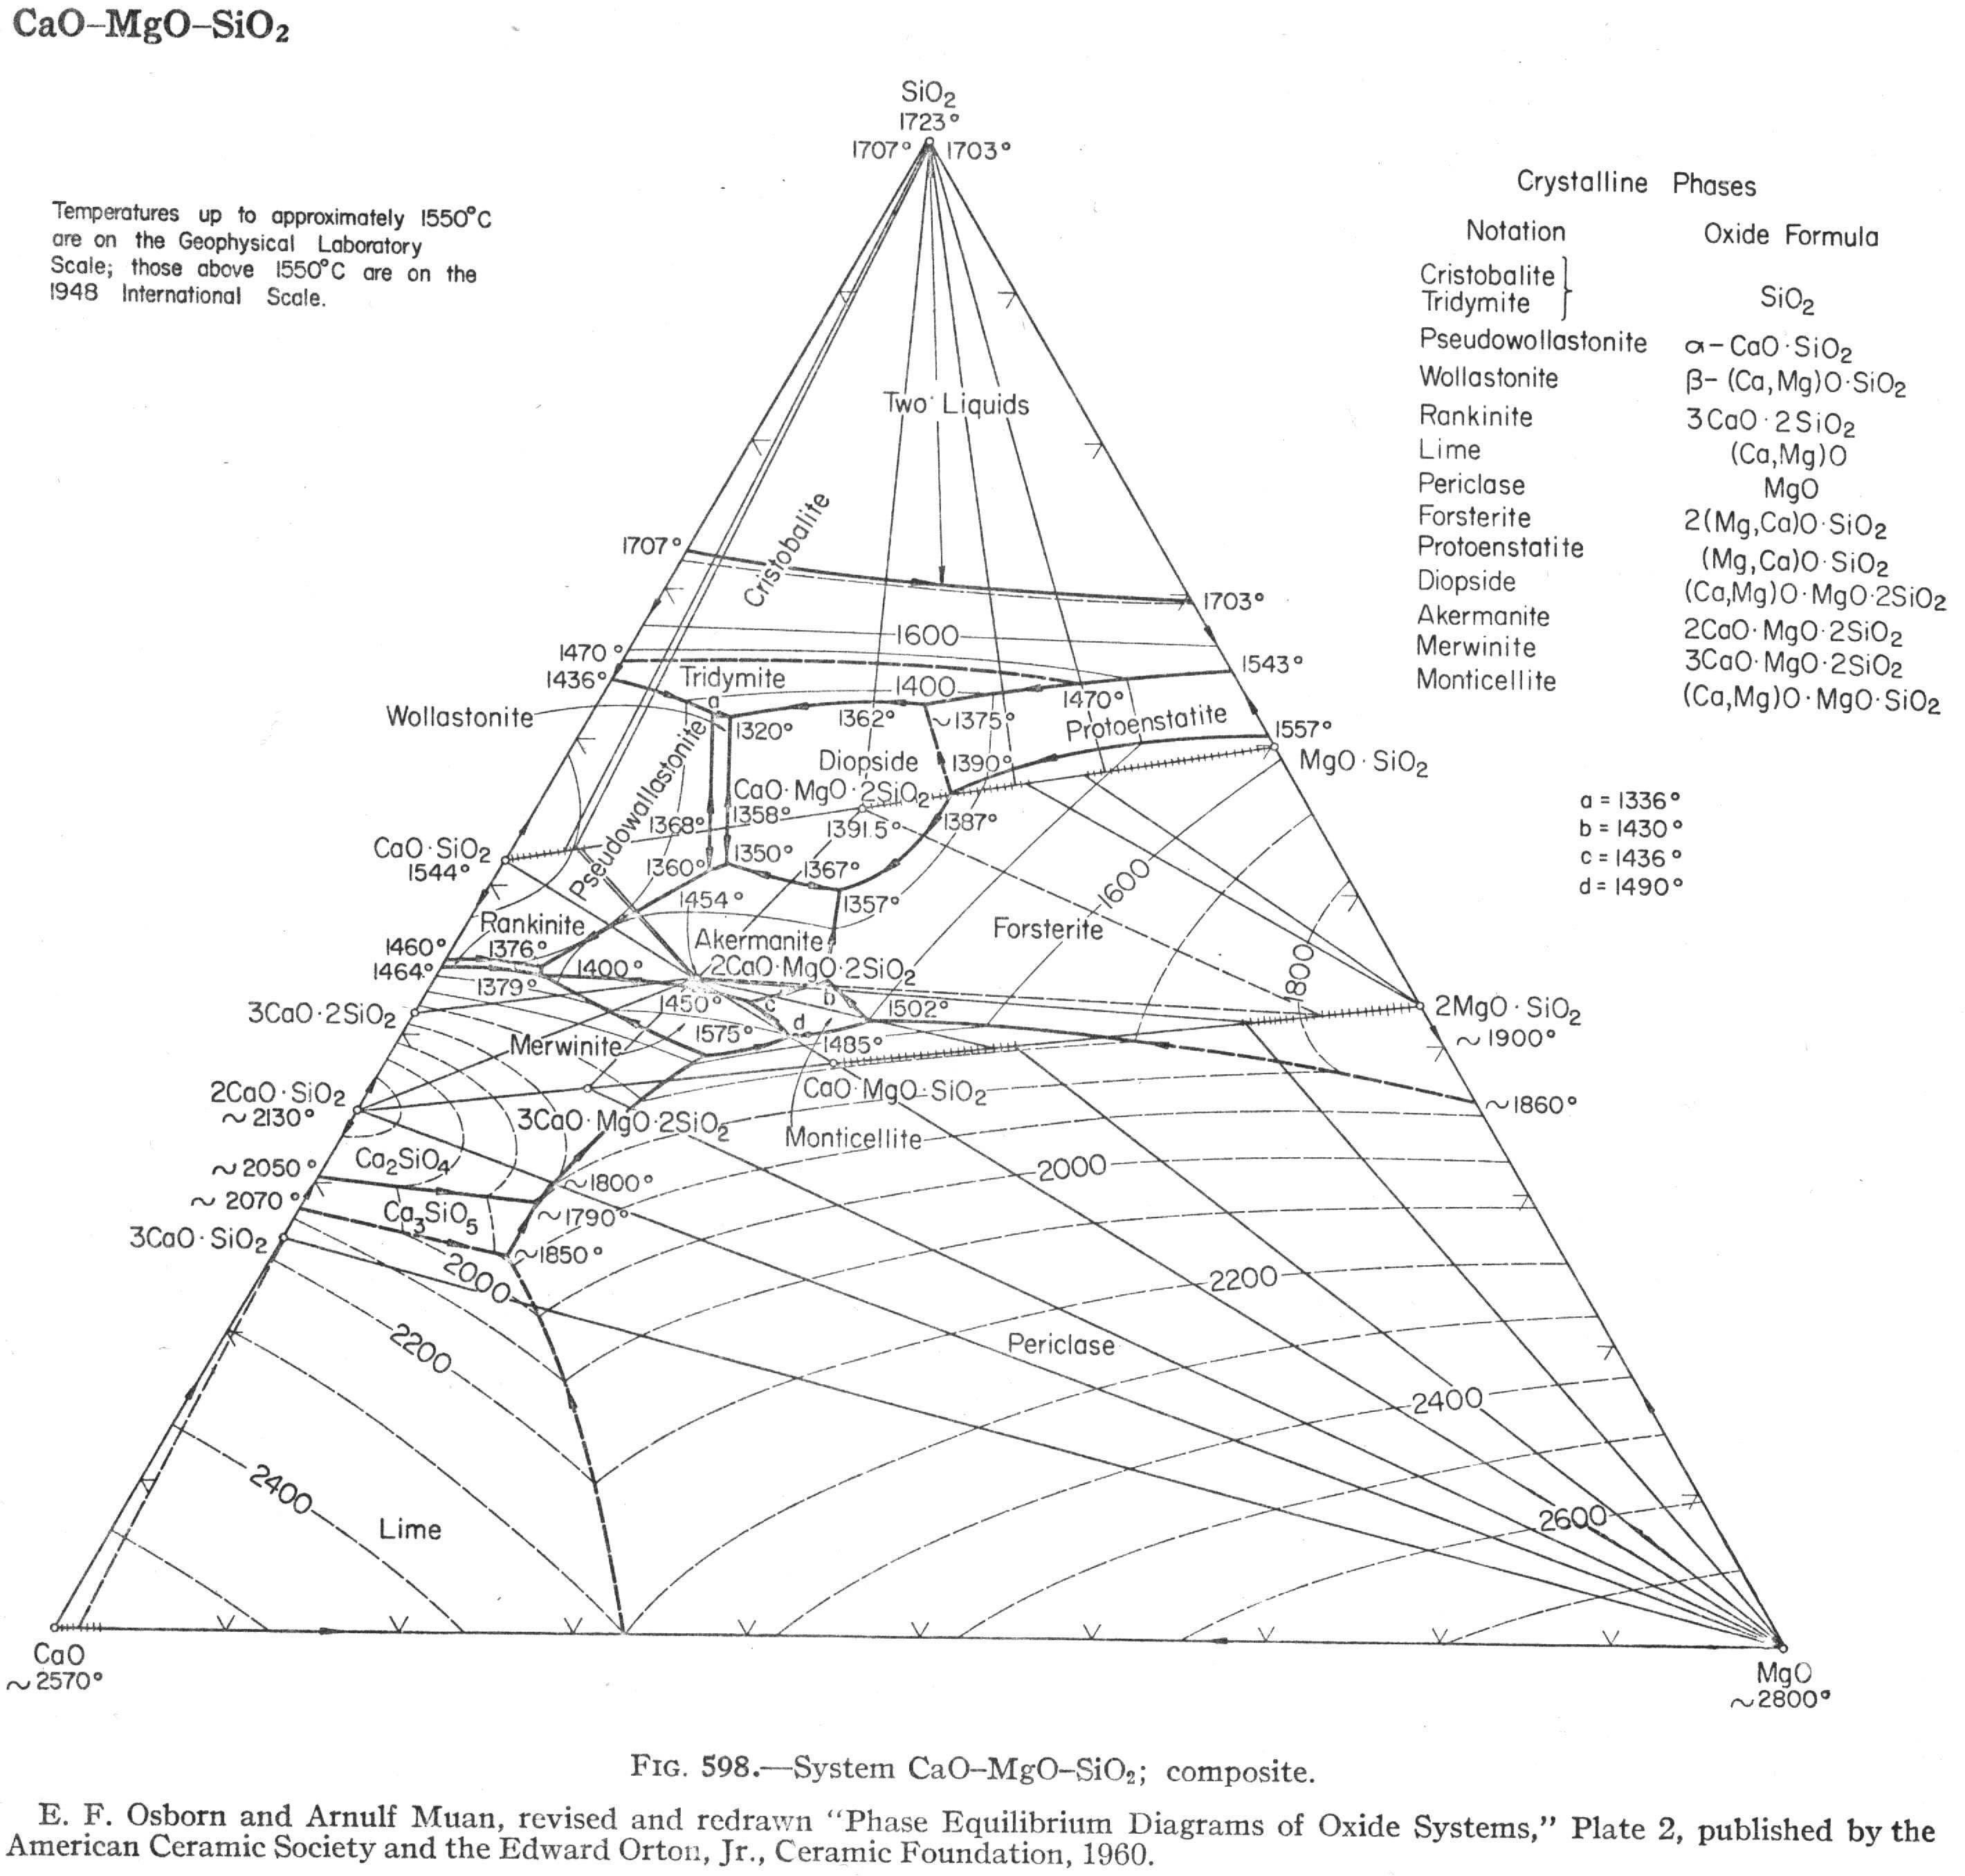
b) 2000 °C

c) 1800 °C

