South Dakota School of Mines and Technology
Department of Materials and Metallurgical Engineering

Met 321 HQ 1 2/18/2009

- Questions on Cost, Conservation, and Concentration
a. Sketch a curve showing how the amount of mineral resource changes with grade.
Increasing Grade
Reserves

b. Sketch a curve showing the Mass of material used per unit Gross Domestic Product for a nation as a function of its per capita Gross Domestic Product.
Mass of material consumed per unit of Gross Domestic Product
Per capita Gross Domestic Product

c. Sketch the trend of inflation-adjusted unit cost of a typical metal during the 20th Century
Unit Cost
Time

d. Sketch the total amount of Cu (as elemental including compounds) on Earth over the 20th Century

Amount

Time

2. Determine the degrees of freedom in each of the following systems:
a) Solid Fe, Solid FeO, gaseous CO, gaseous O₂, and solid C.

b) Add gaseous N₂ to the system (a).

- Add solid Ni and sold NiO to the system (b).

- The three solids: MgO, SiO₂, and CaO at 1 atm

- A system at a fixed temperature and consisting of ZnS, ZnO, SO₂, and O₂.

3. List FOUR methods of producing metals from ores.
a) Give one example of a metal formed by each method and
b) Write a brief (one sentence) description of the method cited.

4. Refer to the attached ternary Phase Diagram for the MgO - SiO₂ - CaO (M, S, C) system.
Consider the batch composition indicated by the black dot near the bottom center of the diagram.

- What is the Bulk Composition of the considered composition?

Characterize the system at the following temperatures:
- 2300 °C - Use the first diagram below to show your construction, etc.
- 2000 °C - Use the second diagram below to show your construction, etc.
- 1800 °C - Use the third diagram below to show your construction, etc.

Show all your work on the following diagrams as indicated. Use symbols for lengths.

b) 2300 °C

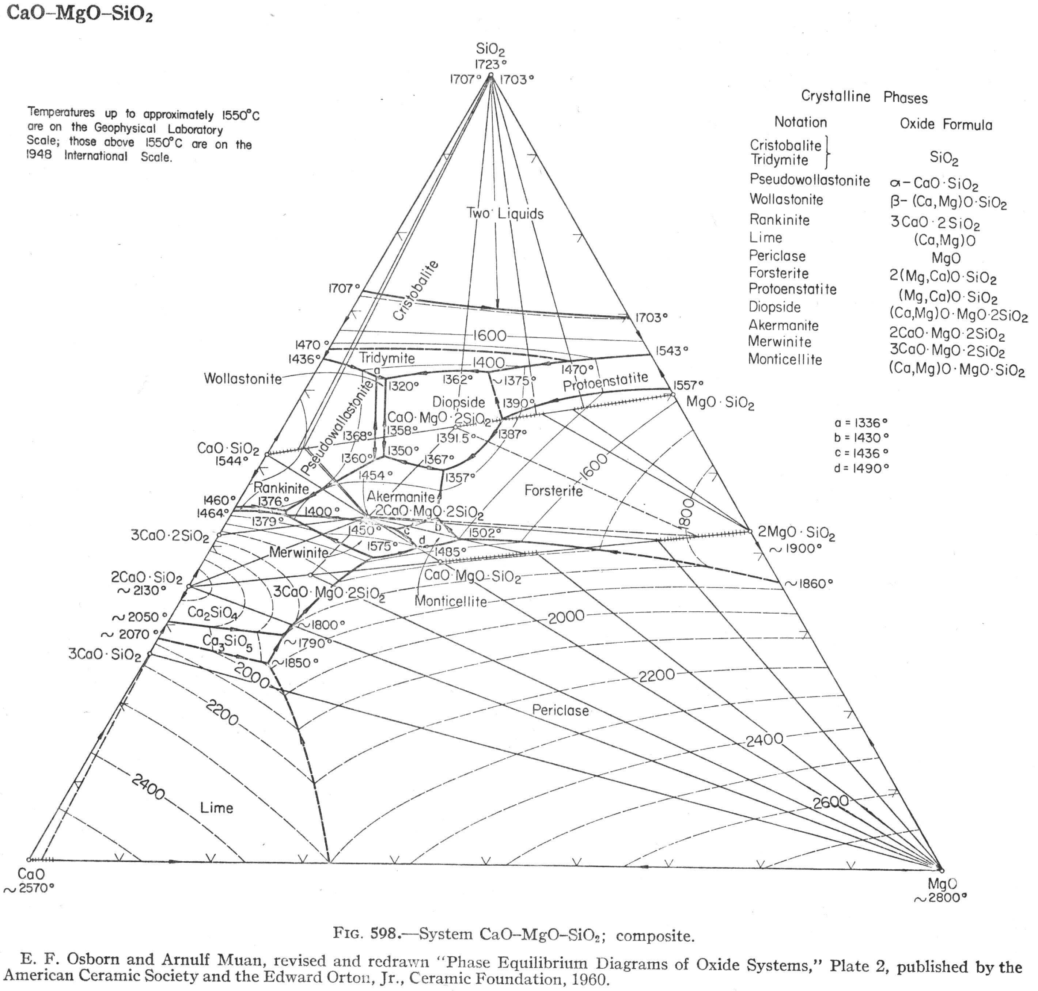
c) 2000 °C

d) 1800 °C

5. Write the mass balances required to solve the following problem:
A zinc flotation concentrate consisting of 90% ZnS and 10% gangue is roasted (burned) in air to ZnO without fuel. The roaster gases contain 6% SO2 and 1% SO3, balance N2 and O2. Give the mass balances needed to calculate the quantity of dry air fed to the roaster per kg of ZnS. Please use the following variables for ease of grading:
x = gmoles of SO₃ in the roaster (exit) gas
y = gmoles of SO₂ in the roaster (exit) gas
u = gmoles of O₂ in the roaster (exit) gas
w = gmoles of N₂ in the roaster (exit) gas
z = gmoles of ZnO produced
n = gmoles of N₂ in the air (input)
p = gmoles of O₂ in the air (input)

Dry is used to “burn” roast the sphalerite.

EQ 1: Dry air ratio
n/p = 21/79 → 79n = 21p

EQ 2: Description of the equation’s basis (or source): ________________________________________

EQ 3: Description of the equation’s basis (or source): ________________________________________

EQ 4: Description of the equation’s basis (or source): ________________________________________

EQ 5: Description of the equation’s basis (or source): ________________________________________

EQ 6: Description of the equation’s basis (or source): ________________________________________

EQ 7: Description of the equation’s basis (or source): ________________________________________

